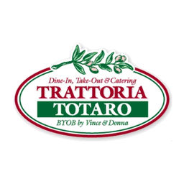

Appetizers:
Roasted Red Peppers, Imported Olives and Sharp Provolone Cheese
Warm Italian bread, garlic olive oil and parmesan cheese
​
Bruschetta
Served with garlic crostini

Enhancements:
Mini Meatballs in marinara sauce… $50

Charcuterie tray with an array of cheeses, meats, fruits, jams, crackers and accompaniments, complete with edible flowers!.... Sm $75 / lg$100.00

Dates wrapped in pancetta
Stuffed with gorgonzola cheese and drizzled with balsamic reduction… $50.00
Entrée:
Served buffet or family style

Host Choose a salad:
Ceaser Salad
Romaine lettuce, fresh ground black pepper and house made croutons
tossed with our cheesy Caesar dressing
Nuts and Berries
​Spring mix, blue cheese, dried cranberries, purple onion and tomato, tossed with berry balsamic dressing, topped with Anas famous chicken salad

Arugula & Burrata
Arugula topped with mozzarella burrata and heirloom tomatoes with olive oil and balsamic reduction

Chicken:
Host choose one
*can be upgraded to veal

Chicken Picatta (gluten free)
Sauteed chicken breast in a white wine caper sauce, with lemon zest topped with fresh lemons

Chicken Parmigiana
Crispy breaded chicken topped with mozzarella cheese & marinara sauce

Chicken Val’Dasta (gluten free)
Pan seared chicken breast topped with prosciutto di Parma, sauteed spinach and mozzarella cheese in a mushroom marsala sauce

Pasta:
Host Choose One:

Rigatoni Abruzzi
Rigatoni pasta in marinara sauce topped with fresh ricotta and basil… delicious and light!

Penne Bolognese
Sauteed ground beef, mushroom, marinara sauce, dash of cream

Vegetable Lasagna (gluten free & vegetarian)
Grilled assortment of vegetables layered with sweet potato risotto and roasted marinara, topped with shredded mozzarella, romano and parmesan cheese

Dessert
Tray of our famous grandoms cakes, cannolis, and macaroons

$35.00 per person

$150 deposit
$150 server fee

